**Distributed Computing**

(CDCSC15)



PRACTICAL FILE

Submitted by:  
Vyom Kaushik

2020UCD2106

CSDS-1(Semester V)

INDEX

|  |  |  |
| --- | --- | --- |
| S. No. | Topic | Pg. No. |
| 1. | Lamport’s Logical Clock. | 3-4 |
| 2. | Lamport's Vector Clock | 4-8 |
| 3. | Distributed Mutual Exclusion | 9-10 |
| 4. | Remote Procedure Call (RPC) | 11-14 |
| 5. | Remote Method Invocation (RMI) | 15-18 |
| 6. | Deadlock Detection | 19-21 |
| 7. | Locking Algorithm | 22-24 |

Practical 1

Aim: Program to implement Lamport’s Logical Clock

Code:

#include <bits/stdc++.h>

using namespace std;

int max1(int a, int b)

{

if(a>b){

return a;

}

return b;

}

void display(int e1, int e2,

int p1[5], int p2[3])

{

int i;

cout <<endl<<"The time stamps of events in P1:"<<endl;

for (i = 0; i < e1; i++) {

cout << p1[i] << " ";

}

cout <<endl<< "The time stamps of events in P2:"<<endl;

for (i = 0; i < e2; i++)

cout << p2[i] << " ";

}

void lamportLogicalClock(int e1, int e2,

int m[5][3])

{

int i, j, k, p1[e1], p2[e2];

// Initialize p1[] and p2[]

for (i = 0; i < e1; i++)

p1[i] = i + 1;

for (i = 0; i < e2; i++)

p2[i] = i + 1;

cout << "\t";

for (i = 0; i < e2; i++)

cout << "\te2" << i + 1;

for (i = 0; i < e1; i++) {

cout << endl<<" e1" << i + 1 << "\t";

for (j = 0; j < e2; j++)

cout << m[i][j] << "\t";

}

for (i = 0; i < e1; i++) {

for (j = 0; j < e2; j++) {

if (m[i][j] == 1) {

p2[j] = max1(p2[j], p1[i] + 1);

for (k = j + 1; k < e2; k++)

p2[k] = p2[k - 1] + 1;

}

if (m[i][j] == -1) {

p1[i] = max1(p1[i], p2[j] + 1);

for (k = i + 1; k < e1; k++)

p1[k] = p1[k - 1] + 1;

}

}

}

// Function Call

display(e1, e2, p1, p2);

}

int main()

{

int e1 = 5, e2 = 3, m[5][3];

m[0][0] = 0;

m[0][1] = 0;

m[0][2] = 0;

m[1][0] = 0;

m[1][1] = 0;

m[1][2] = 1;

m[2][0] = 0;

m[2][1] = 0;

m[2][2] = 0;

m[3][0] = 0;

m[3][1] = 0;

m[3][2] = 0;

m[4][0] = 0;

m[4][1] = -1;

m[4][2] = 0;

// Function Call

lamportLogicalClock(e1, e2, m);

return 0;

}

OUTPUT

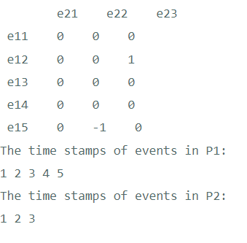

Practical 2

Aim: Lamport's Vector Clock

Code:

#include<iostream>

#include<stdio.h>

#define SIZE 10

using namespace std;

class node {

public:

int data[SIZE];

node *next;

node() {

for(int p=0; p<SIZE; p++) {

data[p] = 0;

}

next = NULL;

}

node(int v[], int n1) {

for(int s = 0; s < n1; s++) {

data[s] = v[s];

}

next = NULL;

}

friend class process;

}*start=NULL;

int main() {

int n, events, sent, receive, sentE, recE, commLines = 0;

node *temp;

node *proc[SIZE]; //array of processes

cout<<"Enter no. of processes: ";

cin>>n;

int vector[n]; //representation of data

for(int i=0;i<n;i++)vector[i]=0;

/*----------------INITIALIZATION LOOP-------------------------*/

for(int i = 0; i < n; i++) { //number of processes

for(int v = 0; v < n; v++) {

vector[v] = 0;

}

cout<<"Enter no. of events in process "<<i+1<<": ";

cin>>events;

for(int j = 1; j <= events; j++) {

vector[i] = j;

node *newnode = new node(vector,n);

if(start == NULL) {

start = newnode;

temp = start;

} else {

temp->next = newnode;

temp = temp->next;

}

}

proc[i] = start;

start = NULL;

}

/*-------------------DATA GATHERING--------------------*/

cout<<"\nEnter the number of communication lines: ";

cin>>commLines;

node *tempS, *tempR;

for(int i = 0; i < commLines; i++) {

cout<<"\nEnter the sending process: ";

cin>>sent;

cout<<"\nEnter the receiving process: ";

cin>>receive;

cout<<"\nEnter the sending event number: ";

cin>>sentE;

cout<<"\nEnter the receiving event number: ";

cin>>recE;

tempS = proc[sent - 1];

tempR = proc[receive - 1];

for(int j = 1; j < sentE; j++)

tempS = tempS->next;

for(int j = 1; j < recE; j++)

tempR = tempR->next;

for(int j = 0; j < n; j++) {

tempR->data[j] = (tempR->data[j] < tempS->data[j]) ? tempS->data[j] : tempR->data[j];

}

}

cout<<"\nThe resulting vectors are:"<<endl<<endl;

for(int k = 0; k < n; k++) {

cout<<"Process "<<k + 1<<": ";

node *temp1 = proc[k];

while(temp1) {

cout<<"(";

for(int f = 0; f < n - 1; f++)

cout<<temp1->data[f]<<",";

cout<<temp1->data[n-1];

cout<<")";

temp1 = temp1->next;

}

cout<<endl;

}

return 0;

}

OUTPUT

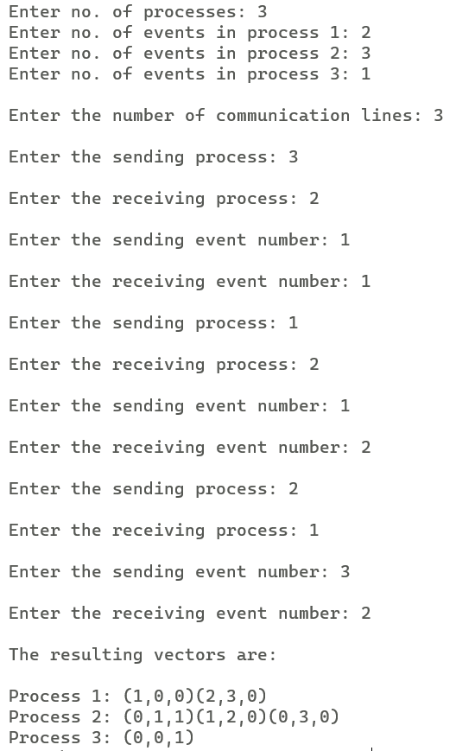

Practical 3

Aim: Distributed Mutual Exclusion (Non-Token Based)

Code:

#include<bits/stdc++.h>

using namespace std;

int main()

{

int ns,ncs,timestamp,site;

cout<<"Enter number of sites :";

cin>>ns;

cout<<"Enter number of sites which want to enter critical section:";

cin>>ncs;

vector<int> ts(ns,0);

vector<int> request;

map <int,int> mp;

for(int i=0;i<ncs;i++)

{

cout<<"\nEnter timestamp:";

cin>>timestamp;

cout<<"Enter site number:";

cin>>site;

ts[site-1]=timestamp;

request.push_back(site);

mp[timestamp]=site;

}

cout<<"\nSites and Timestamp:\n";

for(int i=0;i<ts.size();i++)

{

cout<<i+1<<" "<<ts[i]<<endl;

}

for(int i=0;i<request.size();i++)

{

cout<<"\n Request from site:"<<request[i]<<endl;

for(int j=0;j<ts.size();j++)

{

if(request[i]!=(j+1))

{

if(ts[j]>ts[request[i]-1] || ts[j]==0)

cout<<j+1<<" Replied\n";

else

cout<<j+1<<" Deferred\n";

}

}

}

cout<<endl;

map<int,int>:: iterator it;

it=mp.begin();

int c=0;

for(it=mp.begin();it!=mp.end();it++)

{

cout<<"Site "<<it->second<<" entered Critical Section \n";

if(c==0)

cout<<"\nSimilarly,\n\n";

c++;

}

return 0;

}

OUTPUT

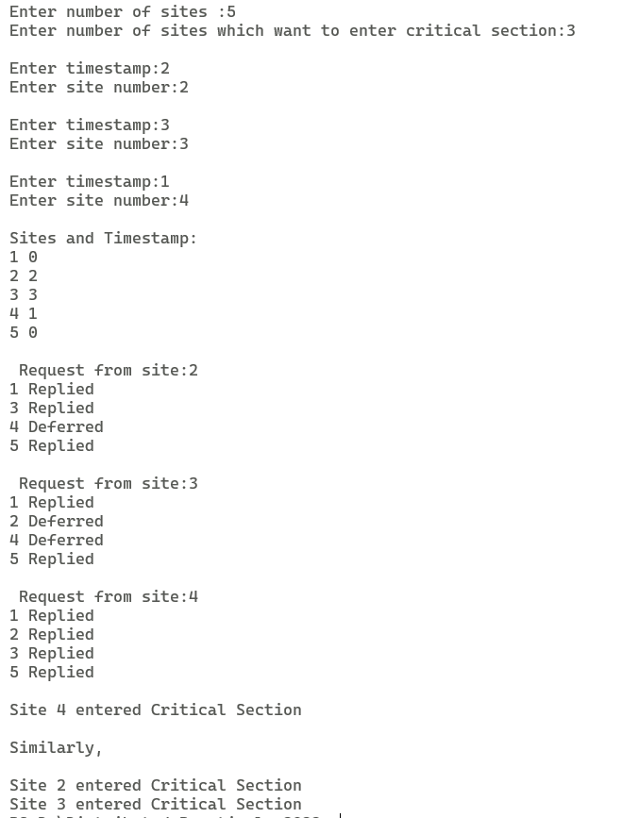

Practical 4

Aim: Remote Procedure Call (RPC)

Code:

**IDL.x**

struct values{

float num1;

float num2;

char operation;

};

program COMPUTE {

version COMPUTE_VERS {

float ADD(values) = 1;

float SUB(values) = 2;

} = 3;

} = 4;

**IDL_client.c**

**/\***

* This is sample code generated by rpcgen.

* These are only templates and you can use them

* as a guideline for developing your own functions.

*/

#include "IDL.h"

float compute_3(char *host, float a, float b, char op)

{

CLIENT *clnt;

float *result_1;

values add_3_arg;

float *result_2;

values sub_3_arg;

if(op == '+') {

add_3_arg.num1 = a;

add_3_arg.num2 = b;

add_3_arg.operation = op;

clnt = clnt_create (host, COMPUTE, COMPUTE_VERS, "udp");

if (clnt == NULL) {

clnt_pcreateerror (host);

exit (1);

}

result_1 = add_3(&add_3_arg, clnt);

if (result_1 == (float *) NULL) {

}

clnt_destroy (clnt);

return (*result_1);

}

else if (op == '-') {

sub_3_arg.num1 = a;

sub_3_arg.num2 = b;

sub_3_arg.operation = op;

clnt = clnt_create (host, COMPUTE, COMPUTE_VERS, "udp");

if (clnt == NULL) {

clnt_pcreateerror (host);

exit (1);

}

result_2 = sub_3(&sub_3_arg, clnt);

if (result_2 == (float *) NULL) {

clnt_perror (clnt, "call failed");

}

clnt_destroy (clnt);

return (*result_2);

}

}

int main (int argc, char *argv[])

{

char *host;

float number1, number2;

char oper;

printf("Enter the first number: ");

scanf("%f", &number1);

printf("Enter the second number: ");

scanf("%f", &number2);

printf("Enter the operator: ");

scanf("%s", &oper);

host = argv[1];

printf("Answer = %f\n", compute_3(host, number1, number2, oper));

exit (0);

}

IDL_server.c

/*

* This is sample code generated by rpcgen.

* These are only templates and you can use them

* as a guideline for developing your own functions.

*/

#include "IDL.h"

float *

add_3_svc(values *argp, struct svc_req *rqstp)

{

static float result;

result = argp->num1 + argp->num2;

return &result;

}

float *

sub_3_svc(values *argp, struct svc_req *rqstp)

{

static float result;

result = argp->num1 - argp->num2;

return &result;

}

**IDL_server.c**

/*

* This is sample code generated by rpcgen.

* These are only templates and you can use them

* as a guideline for developing your own functions.

*/

#include "IDL.h"

float *

add_3_svc(values *argp, struct svc_req *rqstp)

{

static float result;

result = argp->num1 + argp->num2;

return &result;

}

float *

sub_3_svc(values *argp, struct svc_req *rqstp)

{

static float result;

result = argp->num1 - argp->num2;

return &result;

}

OUTPUT

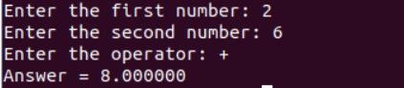

Practical 5

Aim: Remote Method Invocation (RMI)

Code:

We have implemented a Calculator using RMI. The implementation of this program consists of four Java files, namely CalculatorImpl.java, CalculatorServer.java, Calculator.java and CalculatorClient.java.

**Calculator.java:**

// This is an interface

import java.rmi.*;

public interface Calculator extends Remote {

public long add(long a, long b) throws RemoteException;

public long sub(long a, long b) throws RemoteException;

public long mul(long a, long b) throws RemoteException;

public long div(long a, long b) throws RemoteException;

}

**CalculatorImpl.java:**

// This is the implementation file of calculator methods

public class CalculatorImpl extends java.rmi.server.UnicastRemoteObject implements

Calculator {

public CalculatorImpl() throws java.rmi.RemoteException {

super();

}

public long add(long a, long b) {

return a + b;

}

public long sub(long a, long b) {

return a - b;

}

public long mul(long a, long b) {

return a * b;

}

public long div(long a, long b) {

return a / b;

}

}

**CalculatorServer.java**

// This is the server implementing the calculator

import java.rmi.Naming;

public class CalculatorServer {

public CalculatorServer() {

try {

Calculator c = new CalculatorImpl();

Naming.rebind("rmi://localhost:1099/CalculatorService", c);

} catch (Exception e) {

System.out.println("Trouble: " + e);

}

}

public static void main(String args[]) {

new CalculatorServer();

}

}

**CalculatorClient.java**

// This is the actual client program using Calculator interface

import java.rmi.Naming;

import java.rmi.RemoteException;

import java.net.MalformedURLException;

import java.rmi.NotBoundException;

import java.util.*;

public class CalculatorClient {

public static void main(String[] args) {

try {

Calculator c = (Calculator) Naming.lookup("rmi://localhost/CalculatorService");

Scanner sc = new Scanner(System.in);

System.out.print("Enter the first number, a = ");

int a = sc.nextInt();

System.out.print("Enter the second number, b = ");

int b = sc.nextInt();

sc.close();

System.out.println();

System.out.print("The sum of a and b = ");

System.out.println(c.add(a, b));

System.out.print("The difference of a and b = ");

System.out.println(c.sub(a, b));

System.out.print("The product of a and b = ");

System.out.println(c.mul(a, b));

System.out.print("The division of a and b = ");

System.out.println(c.div(a, b));

}

catch (MalformedURLException murle) {

System.out.println();

System.out.println("MalformedURLException");

System.out.println(murle);

}

catch (RemoteException re) {

System.out.println();

System.out.println("Remote Exception");

System.out.println(re);

}

catch (NotBoundException nbe) {

System.out.println();

System.out.println("NotBoundException");

System.out.println(nbe);

}

catch (java.lang.ArithmeticException ae) {

System.out.println();

System.out.println("java.lang.ArithmeticException");

System.out.println(ae);

}

}

}

OUTPUT

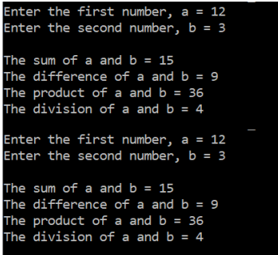

Practical 6

Aim: Remote Deadlock Detection

Code:

#include <bits/stdc++.h>

using namespace std;

bool deadlock(int start, int current, vector<vector<bool>> &depends, vector<bool> &visited, vector<int> &site)

{

if (visited[current])

return true;

visited[current] = true;

for (int i = 0; i < depends[current].size(); i++)

{

if (!depends[current][i])

continue;

if (i == current)

return true;

if (site[current] != site[i])

cout << "Probe is sent: (" << start + 1 << "," << current + 1 << "," << i + 1 << ")" << endl;

return deadlock(start, i, depends, visited, site);

}

return false;

}

int main()

{

int sites;

vector<int> site;

cout << "Enter number of sites: " << endl;

cin >> sites;

int total_no_of_events = 0;

for (int i = 0; i < sites; i++)

{

int events;

cout << "Enter number of events in site " << i + 1 << ": " << endl;

cin >> events;

for (int j = 0; j < events; j++)

site.push_back(i);

total_no_of_events += events;

}

cout << "So, we have " << sites << " sites and " << total_no_of_events << " events numbered " << endl;

for (int i = 1; i <= total_no_of_events; i++)

cout << i << " ";

cout << endl;

vector<vector<bool>> depends(total_no_of_events, vector<bool>(total_no_of_events, false));

int m;

cout << "Enter the no. of dependencies: " << endl;

cin >> m;

for (int i = 0; i < m; i++)

{

int a, b;

cout << "Enter the Dependencies (If event 1 depends on event 2, enter 1 2):" << endl;

cin >> a >> b;

depends[a - 1][b - 1] = true;

}

cout << "Enter the Node to Start Probe: " << endl;

int start;

cin >> start;

start--;

vector<bool> visited(total_no_of_events, false);

if (deadlock(start, start, depends, visited, site))

cout << "A Deadlock exists" << endl;

else

cout << "No Deadlock doesn't exist" << endl;

return 0;

}

OUTPUT

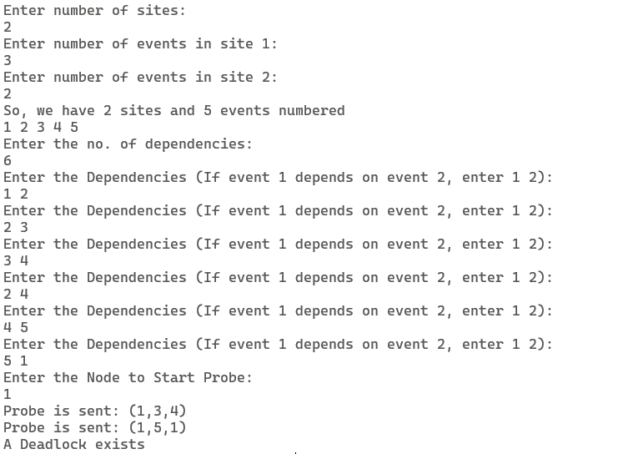

Practical 7

Aim: Locking Algorithm

Code:

#include <bits/stdc++.h>

using namespace std;

int main()

{

int lock = 0;

bool locked_T1 = false, locked_T2 = false;

while (1)

{

int choice;

if (!locked_T1)

{

cout << "Transaction T1 wants to Lock Data Object ?" << endl;

cout << "1. Yes" << endl;

cout << "2. No" << endl;

cin >> choice;

if (!lock && choice == 1)

{

lock = 1;

locked_T1 = true;

cout << "T1 has been given the Lock for the Data Object" << endl;

}

else if (lock)

cout << "\nData Object is Already Locked by " << (locked_T1 ? "T1" : "T2") << endl

<< endl;

}

if (!locked_T2)

{

cout << "Transaction T2 wants to Lock Data Object ?" << endl;

cout << "1. Yes" << endl;

cout << "2. No" << endl;

cin >> choice;

if (!lock && choice == 1)

{

lock = 1;

locked_T2 = true;

cout << "T2 has been given the Lock for the Data Object" << endl;

}

else if (lock)

cout << "\nData Object is Already Locked by " << (locked_T1 ? "T1" : "T2") << endl << endl;

}

if (lock)

{

if (locked_T1)

{

cout << "Transaction T1 wants to Release the Lock on Data Object?" << endl;

cout << "1. Yes" << endl;

cout << "2. No" << endl;

cin >> choice;

if (choice == 1)

{

lock = 0, locked_T1 = false;

cout << "The Lock on Data Object has been released by T1 !" << endl;

}

}

else

{

cout << "Transaction T2 wants to Release the Lock on Data Object?" << endl;

cout << "1. Yes" << endl;

cout << "2. No" << endl;

cin >> choice;

if (choice == 1)

{

lock = 0, locked_T2 = false;

cout << "The Lock on Data Object has been released by T2 !" << endl;

}

}

}

}

return 0;

}

OUTPUT

